**For Each Loop**

This document will explain how to use **For Each Loop**.

Please go through the following sample automation **For Each Loop. Zappy** file.

Enter Separate strings with spaces in this automation.

**Step 1:** Right click on Zap icon and select Task Editor (or Double click on zap icon).

**Step 2:** Open the **“For Each Loop. Zappy”** file.

**Step 3:** To start the execution click on start .

**Step 4:** Enter a long string separate with spaces, and then click on **OK**.

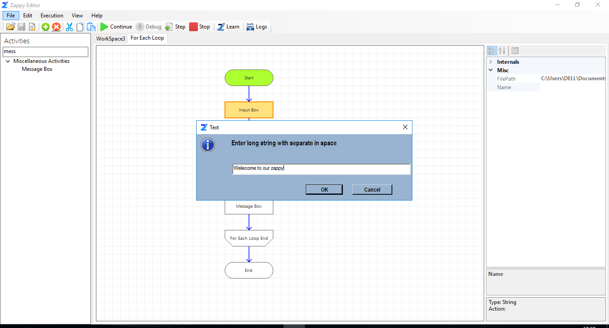

**Step 6:** The message box will be showing each string, then you click on the OK.

